Watch this video Simon Sinek Start with WHY: https://www.youtube.com/watch?v=IPYeCltXpxw

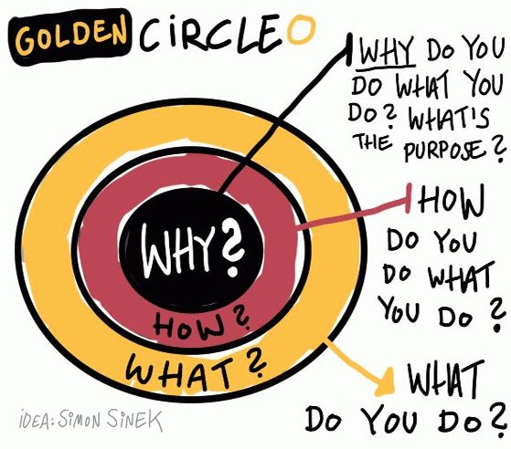

What’s my why? Why did I become an educator?

What’s my union’s why?

B.R.A.G. Sheet

Benefits – What are the advantages of membership in our union? (i.e. A collective voice for public education) | Resources – How does my union support me and help me be the best educator I can be?
Achievements – What have we achieved that makes a difference in the lives of my students? | Goals – What achievements are we (or should we) working to accomplish that will make a difference in the lives of my students?

