HAVE YOU
VOTED YET?
Vote YES to Support Your Colleagues and RECERTIFY the
WAWM Education Association
The recertification vote is conducted via telephone. Please follow these steps to show your support:
Directions for Voting by Phone:
- Call the recertification voting line: 1-866-458-9862;
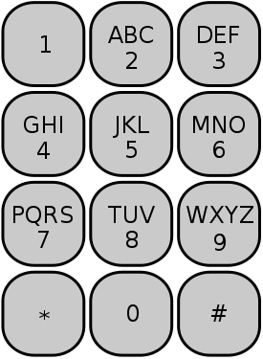
- When prompted, confirm your identity by entering the first 4 letters of your LAST NAME, then the last 4 digits of your Social Security Number. The image to the left shows which letters are associated with the telephone keypad numbers;
- When prompted, VOTE YES to recertify your union(if given another union name, hang up see below);
- After voting, STAY ON THE LINE and CONFIRM YOUR VOTE. Do not hang up until you receive a “thank you” message so that your vote is counted unless given the wrong union/district info.
Directions for Voting Online:
- Go to http://www.aaaelections.org/WERC and following the on-screen instructions for online voting, or use the QR Scanner to the right on your smartphone to access online voting - Make sure the correct union/school district name is provided:

Important Online Voting Tips:
- Make sure you VOTE YES for recertification and submit your vote.
- CONFIRM your vote by selecting “yes” again.
- Wait until you are informed your vote was successfully processed before leaving the site so your vote is counted.
Additional Information:
- Your vote is secret;
- You can vote 24 hours a day during the voting window. A helpdesk is available 10 AM to 6 PM Monday through Friday (1-800-529-5218);
- All employees in a bargaining unit vote, not just union members;
- The union needs to win 51% of all unit employees to recertify, which means that not voting is the same as voting no. Your colleagues need your support, so please vote YES.
- If the prompt gives you the name of another local union, hang up and call your Regional Director.
- If you have problems casting your vote, report the problem as instructed and report it to your Regional Director anytime, Steven Cupery at 262-853-5142 or CuperyS@weac.org Note WAWM EA/ Voter problem in subject line.

Don’t delay – VOTE EARLY. Votes may be cast any time during the voting window.

Our voting window ends
Noon on Tuesday, November 24th

