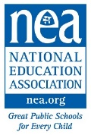
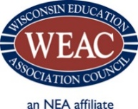
WEAC WELCOME PROGRAM 2021
Micro-Grant Application
- Grants are to increase outreach, engagement and leadership of early career educators.
- Micro-grant applications are accepted through October 1. However, there is limited funding and when it is exhausted, no further grants can be awarded.
Date: | Local Name:
Contact: |  |  | Contact Role:
Cell Phone: |  |  | Home Phone:
Personal E-mail:

# of Members: |  | # of Potential Members: |  | # of New Hires:
Grant Request Amount (up to $500):

Event 1 Offering*:
Event 2 Offering*:
*If you are unsure, indicate you would like help. We will contact you to help collaborate on the best offerings to suit your Local’s needs.

Micro-Grant Requirements:
- Create and share a qualifying membership & new hire orientation plan;
- Offer two programs with a focus on new hires. One of the programs must be a professional development event (fall and winter/spring);
Examples of previous approved grants:
  - Grant for new hires to attend WEAC new educator conference in early fall
  - New hire social
Professional Development Grant examples:
  - Classroom Management
  - Know your legal rights
  - Student Debt
  - How to work with parents & administrators
- Submit a simple list of projected costs for each event;
- Collect Interest Cards from new hires & follow-up with new hires;
- Forward a mid-year and end of year report to WEAC including sign-up sheets from event; and
- Participation in a membership or organizing training program. Priority will be given to those that attend a WEAC sponsored event.

By accepting a grant, our Local agrees to provide a preliminary report on progress, including sign-in sheets of participants, to WEAC by December 15, 2020 and a final report to WEAC by April 15, 2021. I understand that if I do not file reports and forward receipts, additional funds will not be released to our local and future micro-grants will not be awarded.

Signature: __________________________________________ Date: ________________________

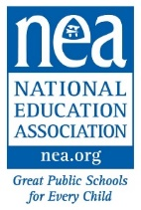
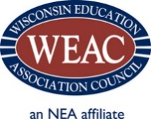
Local Association Membership Plan

Local Education Association and Contact Name

MEMBERSHIP GOAL (select a target number of new members for 2020-21):

WHAT’S YOUR PLAN TO GET NEW HIRE LISTS AND TO PARTICIPATE IN NEW EMPLOYEE ORIENTATION?

WHAT’S YOUR PLAN TO SUPPORT AND TRAIN BUILDING REPS AND WORK SITE LEADERS?

WHAT’S YOUR STRATEGY FOR CONNECTING WITH NEW HIRES IN EVERY BUILDING?

WHAT’S YOUR PLAN TO FOLLOW-UP WITH ALL NEW HIRES?

NAME A LOCAL SOCIAL AND AT LEAST ONE PROFESSIONAL DEVELOPMENT OPPORTUNITY FOR EARLY EDUCATORS
(e.g. meet & greet, classroom management workshop; parent teacher conference roundtable.)
Unsure on what would best suit? Just ask and we can help you
FALL:
WINTER:

