Hello,

I wanted to start off with thanking AE members these past couple of years. Juggling in-person, virtual, and hybrid meetings (oh my!) in tandem with student teaching in a pandemic is no small feat! We appreciate you sticking with us as we navigate how to restart the college student organization experience while also minding the pandemic fatigue and new lives the pandemic has shaped for each and every one of us.

This packet is going to differ from the packets of previous “leadership handbooks”. Through my time as President working with the state board and meeting other members and leaders throughout the state, it is clear to me that organizationally we are strong as individual chapters. Chapters have their annual traditions and procedures that help them to retain and train the next waves of members.

Instead, this packet will focus on the new updated role the e-board took this year in terms of state leadership.

Thank you,

Sofia Vandersluis
State President 2021-2022

BOD Format

The biggest change in how state procedures were handled this year came from the new (and improved) format of BOD meetings. AE BOD meetings are now Professional Development Sessions rather than solely WEAC and membership updates. As BODs are the collection of AE leaders from across the state, I wanted to take that time to better our practice as future educators. Many of our education programs work in the world of abstracts leaving many of us confused as to “what do we actually do?”. By creating Professional Development focused BODs, meetings became more than personified emails but opportunities to learn and grow with future educators all over the state of Wisconsin—which is what AE is all about.

We have had 3 BODs this year. 2 of them followed the above PD format, and one was a pdf email that was sent to chapters. In accordance with WEAC budgeting, one AE meeting a year needs to be held “virtually”. Personally, the idea of keeping people’s weekend hostage by presenting a zoom meeting that could frankly we a pdf seemed wrong to me. I understand that it was not the most effective means of communication but in the year of getting back to in-person and normality amidst HEAVY zoom fatigue from last year, it felt right.

The PD BODs are listed below:

August BOD
This BOD’s theme was “Finding our Why”. After the virtual year and the messaging about Education systems in distress being an education student is, frankly, scary. I wanted to take the opportunity to help ground state leaders in why we are here. Everyone finds and goes into teaching for an immensely personal reason, and I think that is an important emotion to hold close during teacher education. We had NEA leader Shelly Krajacic come speak about finding her why and her talk was inspiring.

October BOD
This BOD’s theme was “Tech in Education”. The pandemic fast tracked that technology is the new language of education. Generally, teacher education students find discomfort around tech and I thought a BOD would be a good time to introduce how to incorporate and operate it in our classrooms, turning a point of insecurity into one of marketable confidence. We had two speakers run sessions throughout this BOD. Our first speaker was Jake Krueger, VP 2020-2021. He introduced us to tech he uses in his classroom in engage students and help him to better track his student’s data. The other speaker was from Merit Library (the teacher education library on UW Madison’s campus). This talk focused on the nuts and bolts of tech in classrooms and gave leaders a thorough run through on how to use and operate items like smartboards, projectors, speakers… the basic instruments we would run into in classrooms.

BOD Socials

Almost as important to the new format of BODs was the accompanying social. AE is a social organization when it is its best. It is a way for teacher education students to connect from all across the state. Socials help to break the ice between chapters before the BOD.

This year we had two socials. At the August BOD the social was an Amazing Race throughout Madison (hitting spots with educational themes) that ended at Memorial Union’s terrace where leaders had ice cream and connected.

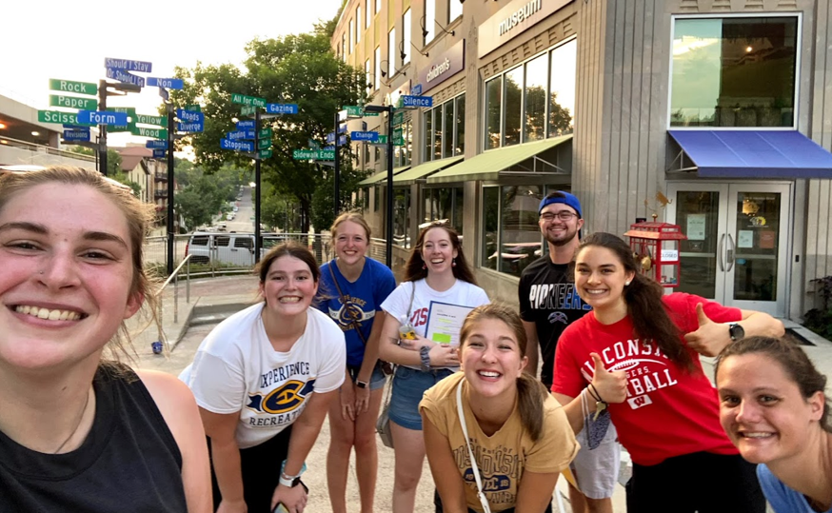

At the October BOD leaders went to a farm outside of Madison for a bonfire and night corn maze.
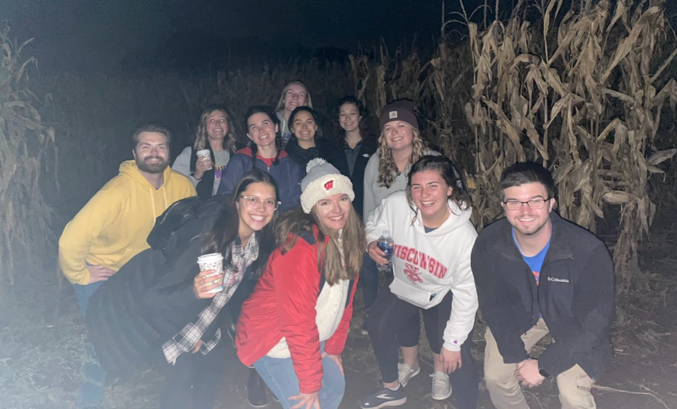

In terms of organization, for the socials and BODs I asked members to wear “merch” from their respective school. This allowed a nice visual spread of the representation and made it easy for me to mix people up in the ice breaker activities so we could foster co-chapter relationships.

2021-2022 State Projects

We had two major “drives” this year at the state level of AE. Two were led by the President and the other by the VP.

Teachers Support Teachers was led by me (President). Teachers Support Teachers is a donation drive where chapters were encouraged to raise money to surprise local schools in their area with coffee and donuts to express our appreciation of their work. This was mildly successful, a trend seen throughout the year was chapters were so focused on getting back to where they were pre-pandemic it was hard to add more onto their agendas. Teachers Support Teacher ran twice, once in November and then in February being the most successful in Madison and Eau Claire.

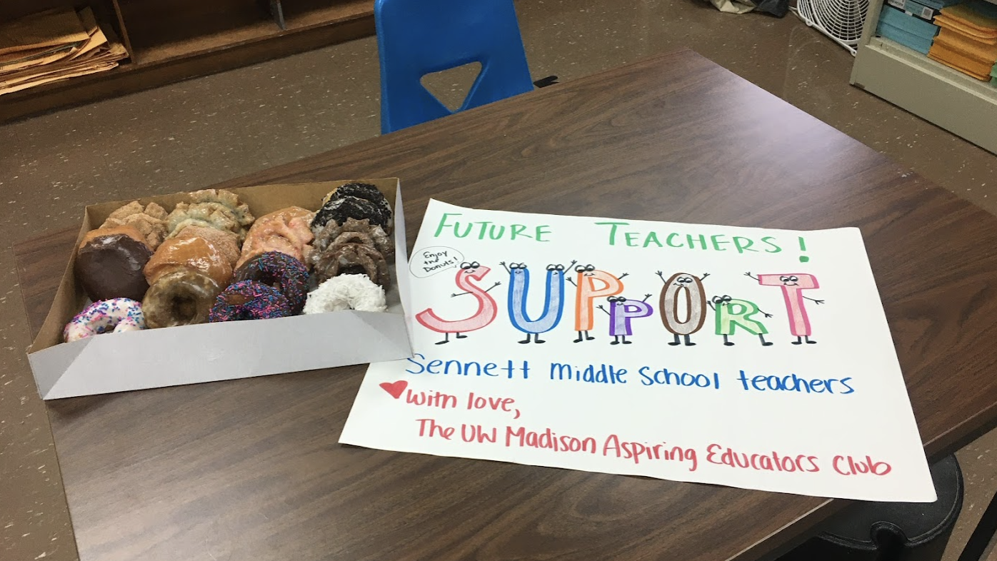

The other project lead by the president was the collection of local chapter websites. In August I asked chapters to create websites that would act as “blogs” to help with our forming of relationships with local unions in our areas. Websites included important contact information, events, and fundraising that chapters were working on. During the summer (2022) I will be working with the new President to get these URLs coded onto the WEAC AE page.

The last drive was led by the VP. It was a scholastic book fair. At the time this is being written it is going on so notes on the May BOD will have more information about success.

