HAVE YOU
VOTED YET?
Vote YES to Support Your Colleagues and RECERTIFY the
[Name] Education Association
The recertification vote is conducted via telephone. Please follow these steps to show your support:
Directions for Voting by Phone:
- Call the recertification voting line: 1-866-458-9862;
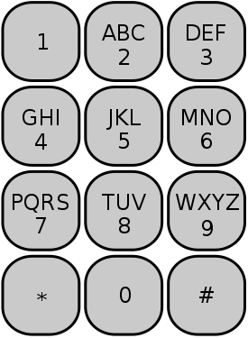
- When prompted, confirm your identity by entering the first 4 letters of your LAST NAME, then the last 4 digits of your Social Security Number. The image to the left shows which letters are associated with the telephone keypad numbers;
- When prompted, VOTE YES to recertify your union(if given another union name, hang up see below);
- After voting, STAY ON THE LINE and CONFIRM YOUR VOTE. Do not hang up until you receive a “thank you” message so that your vote is counted unless given the wrong union/district info.
Directions for Voting Online:
- Go to http://www.aaaelections.org/WERC and following the on-screen instructions for online voting, or use the QR Scanner to the right on your smartphone to access online voting - Make sure the correct union/school district name is provided:

Important Online Voting Tips:
- Make sure you VOTE YES for recertification and submit your vote.
- CONFIRM your vote by selecting “yes” again.
- Wait until you are informed your vote was successfully processed before leaving the site so your vote is counted.
Additional Information:
- Your vote is secret;
- You can vote 24 hours a day during the voting window. A helpdesk is available 10 AM to 6 PM Monday through Friday (1-800-529-5218);
- All employees in a bargaining unit vote, not just union members;
- The union needs to win 51% of all unit employees to recertify, which means that not voting is the same as voting no. Your colleagues need your support, so please vote YES.
- If the prompt gives you the name of another local union, hang up and call your Regional Director.
- If you have problems casting your vote, report the problem as instructed and report it to your Regional Director anytime. Note WAWM EA/ Voter problem in subject line.

Don’t delay – VOTE EARLY. Votes may be cast any time during the voting window.

Our voting window ends
Noon on Monday, November 21

